**Day-7 | Azure Networking Demo | Azure VNet, Firewall, NSG and Bastion | Beginner Level Azure Project**

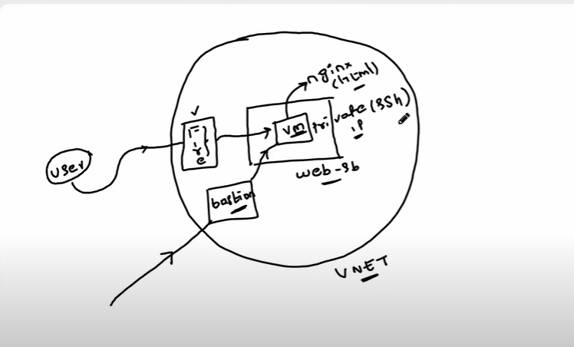

# Azure Bastion

## Protect your virtual machines with more secure remote access

Azure Bastion is a fully managed service that provides more secure and seamless Remote Desktop Protocol (RDP) and Secure Shell Protocol (SSH) access to virtual machines (VMs) without any exposure through public IP addresses. Provision the service directly in your local or peered virtual network to get support for all the VMs within it.

Azure Firewall

Azure Firewall decrypts outbound traffic, performs required security checks, and then encrypts the traffic to the destination.

Azure firewall are applied for both inbound and outbound traffic for a particular

Virtual network.

------------------------------------------------------

Create a azure VM, and OS as Linux

# Install and Configure Nginx on Ubuntu

## Step 1: Update Package Lists

Before installing any new software, it's a good practice to update the package lists to ensure you get the latest version.

sudo apt update

sudo apt upgrade

## Step 2: Install Nginx

Install Nginx using the following command:

sudo apt install nginx

## Step 3: Start Nginx Service

sudo systemctl start nginx

## Step 4: Create HTML File

sudo vim /var/www/html/index.html

Add the HTML content, for example.

<!DOCTYPE html>

<html lang="en">

<head>

<meta charset="UTF-8">

<meta name="viewport" content="width=device-width, initial-scale=1.0">

<title>Demo Page</title>

</head>

<body>

<h1> I Learnt how networking works in Azure today</h1>

</body>

</html>

Save the file.

### Restart Nginx

sudo systemctl restart nginx

To make sure the request is tracked and apply some policies:

1. Search for firewall or resource group and go in that firewall
2. 2) Go in firewall policy
3. Add rule collection

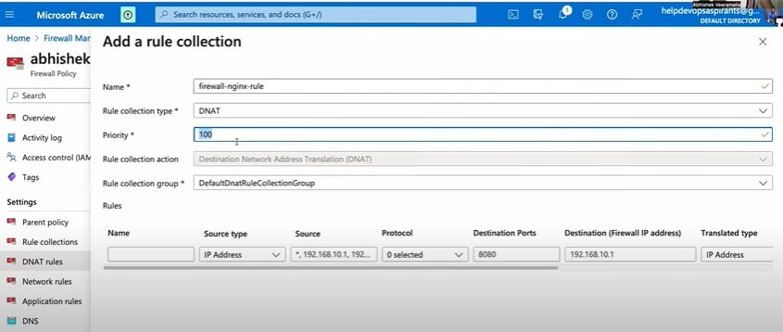

4)Add DNAT Rules:

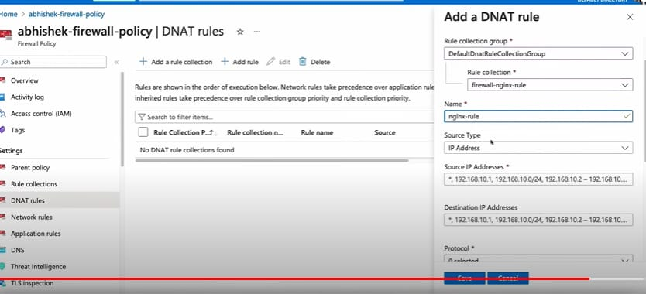

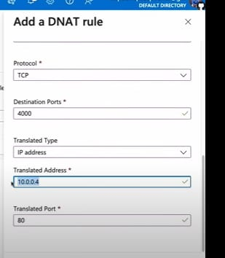

Priority: least is 100 and max is 65000

Whichever has the least number has the maximum priority.